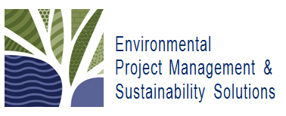

Environmental Project Management & Sustainability Solutions

3801 Weir Road | Spencerville, ON | K0E 1X0 | T: 613.760.6918 | W: www.envpmsolutions.ca

Request More Information: Bring an ENVPMSS Class to your Company
If you would like more information regarding hosting a training course, please complete the short form below and send to: training@dgslearningcentre.com. Once your request is received, we will contact you to answer any questions you may have.

Your Contact Information  All Fields are Required |  | Which Courses are you Interested In?
First Name: |  | Project Management Fundamentals  ☐ Project Management Planning Essentials
Last Name: |  | Advanced Project Management  ☐ Project Stakeholder Management
Title: |  | In the space provided below, please list any other PM Topics you may be interested in, or describe any customizations you may need to the courses you’ve selected above.
Company:
City:
Country:
Phone:
Email Address:
Describe Yourself  Please select one of the following: |  | Interested in other modes of learning?  Please check all that apply
☐ I am collecting information for a decision maker  ☐ I report directly to someone who can approve training contracts  ☐ I can approve training contracts for my organization |  | ☐ Self-directed Online E-learning  ☐ Live Online Instructor-led Class

